*Commands*

***gawk*** - pattern scanning and processing language

SYNOPSIS

gawk [ POSIX or GNU style options ] -f program-file [ -- ] file

gawk [ POSIX or GNU style options ] [ -- ] program-text file ...

pgawk [ POSIX or GNU style options ] -f program-file [ -- ] file

pgawk [ POSIX or GNU style options ] [ -- ] program-text file ...

DESCRIPTION

Gawk is the GNU Project's implementation of the AWK programming language. It conforms to the definition of the language in the POSIX 1003.1 Standard

OPTIONS

-F fs

--field-separator fs

Use fs for the input field separator (the value of the FS predefined variable).

-v var=val

--assign var=val

Assign the value val to the variable var, before execution of the program begins. Such variable values are available to the BEGIN block of an AWK

program.

-f program-file

--file program-file

Read the AWK program source from the file program-file, instead of from the first command line argument. Multiple -f (or --file) options may be used.

***basename*** - strip directory and suffix from filenames

SYNOPSIS

basename NAME [SUFFIX]

basename OPTION

DESCRIPTION

Print NAME with any leading directory components removed. If specified, also remove a trailing SUFFIX.

--help display this help and exit

--version

output version information and exit

***bc*** - An arbitrary precision calculator language

SYNTAX

bc [ -hlwsqv ] [long-options] [ file ... ]

DESCRIPTION

bc is a language that supports arbitrary precision numbers with interactive execution of statements.

OPTIONS

-h, --help

Print the usage and exit.

-i, --interactive

Force interactive mode.

-l, --mathlib

Define the standard math library.

-w, --warn

Give warnings for extensions to POSIX bc.

-s, --standard

Process exactly the POSIX bc language.

## *break*

afs_syscall, break, ftime, getpmsg, gtty, lock, madvise1, mpx, prof, profil, putpmsg, security, stty, tuxcall, ulimit, vserver - unimplemented system calls

SYNOPSIS

Unimplemented system calls.

DESCRIPTION

These system calls are not implemented in the Linux 2.6.22 kernel.

***cal*** - displays a calendar and the date of Easter

SYNOPSIS

cal [-hjy] [[month] year]

cal [-hj] -m month [year]

ncal [-hjJpwy3] [-s country_code] [[month] year]

ncal [-hJeo] [year]

DESCRIPTION

The cal utility displays a simple calendar in traditional format and ncal offers an alternative layout, more options and the date of Easter. The new format

is a little cramped but it makes a year fit on a 25x80 terminal. If arguments are not specified, the current month is displayed.

The options are as follows:

-3 Print the previous month, the current month, and the next month all on one row.

-h Turns off highlighting of today.

-J Display Julian Calendar, if combined with the -e option, display date of Easter according to the Julian Calendar.

-e Display date of Easter (for western churches).

***cat*** - concatenate files and print on the standard output

SYNOPSIS

cat [OPTION]... [FILE]...

DESCRIPTION

Concatenate FILE(s), or standard input, to standard output.

-A, --show-all

equivalent to -vET

-b, --number-nonblank

number nonempty output lines

-e equivalent to -vE

-E, --show-ends

display $ at end of each line

-n, --number

number all output lines

***chmod*** - change file mode bits

SYNOPSIS

chmod [OPTION]... MODE[,MODE]... FILE...

chmod [OPTION]... OCTAL-MODE FILE...

chmod [OPTION]... --reference=RFILE FILE...

DESCRIPTION

chmod changes the file mode bits of each given file according to mode, which can be either a symbolic representation of changes to make, or an octal number representing the bit pattern for the new mode bits.

OPTIONS

Change the mode of each FILE to MODE.

-c, --changes

like verbose but report only when a change is made

--no-preserve-root

do not treat `/' specially (the default)

--preserve-root

-f, --silent, --quiet

suppress most error messages

-v, --verbose

output a diagnostic for every file processed

***clear*** - clear the terminal screen

SYNOPSIS

clear

DESCRIPTION

clear clears your screen if this is possible. It looks in the environment for the terminal type and then in the terminfo database to figure out how to clear the screen.

***cmp*** - compare two files byte by byte

SYNOPSIS

cmp [OPTION]... FILE1 [FILE2 [SKIP1 [SKIP2]]]

DESCRIPTION

Compare two files byte by byte.

-b --print-bytes

Print differing bytes.

-i SKIP --ignore-initial=SKIP

Skip the first SKIP bytes of input.

-i SKIP1:SKIP2 --ignore-initial=SKIP1:SKIP2

Skip the first SKIP1 bytes of FILE1 and the first SKIP2 bytes of FILE2.

-l --verbose

Output byte numbers and values of all differing bytes.

-n LIMIT --bytes=LIMIT

Compare at most LIMIT bytes.

***comm*** - compare two sorted files line by line

SYNOPSIS

comm [OPTION]... FILE1 FILE2

DESCRIPTION

Compare sorted files FILE1 and FILE2 line by line.

With no options, produce three-column output. Column one contains lines unique to FILE1, column two contains lines unique to FILE2, and column three contains lines common to both files.

*cp* - copy files and directories

SYNOPSIS

cp [OPTION]... [-T] SOURCE DEST

cp [OPTION]... SOURCE... DIRECTORY

cp [OPTION]... -t DIRECTORY SOURCE...

DESCRIPTION

Copy SOURCE to DEST, or multiple SOURCE(s) to DIRECTORY.

Mandatory arguments to long options are mandatory for short options too.

-a, --archive

same as -dR --preserve=all

--backup[=CONTROL]

make a backup of each existing destination file

-b like --backup but does not accept an argument

--copy-contents

copy contents of special files when recursive

-d same as --no-dereference --preserve=links

-f, --force

if an existing destination file cannot be opened, remove it and try again (redundant if the -n option is used)

***cut*** - remove sections from each line of files

SYNOPSIS

cut OPTION... [FILE]...

DESCRIPTION

Print selected parts of lines from each FILE to standard output.

Mandatory arguments to long options are mandatory for short options too.

-b, --bytes=LIST

select only these bytes

-c, --characters=LIST

select only these characters

-d, --delimiter=DELIM

use DELIM instead of TAB for field delimiter

-f, --fields=LIST

select only these fields; also print any line that contains no delimiter character, unless the -s option is specified

***date*** - print or set the system date and time

SYNOPSIS

date [OPTION]... [+FORMAT]

date [-u|--utc|--universal] [MMDDhhmm[[CC]YY][.ss]]

DESCRIPTION

Display the current time in the given FORMAT, or set the system date.

-d, --date=STRING

display time described by STRING, not `now'

-f, --file=DATEFILE

like --date once for each line of DATEFILE

-r, --reference=FILE

display the last modification time of FILE

-R, --rfc-2822

output date and time in RFC 2822 format. Example: Mon, 07 Aug 2006 12:34:56 -0600

***dc*** - an arbitrary precision calculator

SYNOPSIS

dc [-V] [--version] [-h] [--help]

[-e scriptexpression] [--expression=scriptexpression]

[-f scriptfile] [--file=scriptfile]

[file ...]

DESCRIPTION

dc is a reverse-polish desk calculator which supports unlimited precision arithmetic. It also allows you to define and call macros. Normally dc reads from the standard input.

OPTIONS

dc may be invoked with the following command-line options:

-V

--version

Print out the version of dc that is being run and a copyright notice, then exit.

-h

--help Print a usage message briefly summarizing these command-line options and the bug-reporting address, then exit.

-e script

***df*** - report file system disk space usage

SYNOPSIS

df [OPTION]... [FILE]...

DESCRIPTION

This manual page documents the GNU version of df. df displays the amount of disk space available on the file system containing each file name argument.

OPTIONS

Show information about the file system on which each FILE resides, or all file systems by default.

-a, --all

include dummy file systems

-B, --block-size=SIZE

use SIZE-byte blocks

--total

produce a grand total

-h, --human-readable

print sizes in human readable format (e.g., 1K 234M 2G)

-H, --si

likewise, but use powers of 1000 not 1024

***dir*** - list directory contents

SYNOPSIS

dir [OPTION]... [FILE]...

DESCRIPTION

List information about the FILEs (the current directory by default). Sort entries alphabetically if none of -cftuvSUX nor --sort.

Options-

-a, --all

do not ignore entries starting with .

-A, --almost-all

do not list implied . and ..

--author

with -l, print the author of each file

-b, --escape

print octal escapes for nongraphic characters

--block-size=SIZE

use SIZE-byte blocks

-B, --ignore-backups

***diff*** - compare files line by line

SYNOPSIS

diff [OPTION]... FILES

DESCRIPTION

Compare files line by line.

Options-

-i --ignore-case

Ignore case differences in file contents.

--ignore-file-name-case

Ignore case when comparing file names.

--no-ignore-file-name-case

Consider case when comparing file names.

-E --ignore-tab-expansion

Ignore changes due to tab expansion.

-b --ignore-space-change

Ignore changes in the amount of white space.

***du* - estimate file space usage**

SYNOPSIS

du [OPTION]... [FILE]...

du [OPTION]... --files0-from=F

DESCRIPTION

Summarize disk usage of each FILE, recursively for directories.

Options.

-a, --all

write counts for all files, not just directories

--apparent-size

print apparent sizes, rather than disk usage; although the apparent size is usually smaller, it may be larger due to holes in (`sparse') files,

internal fragmentation, indirect blocks, and the like

-B, --block-size=SIZE

use SIZE-byte blocks

-b, --bytes

equivalent to `--apparent-size --block-size=1'

-c, --total

produce a grand total

***echo*** - display a line of text

SYNOPSIS

echo [SHORT-OPTION]... [STRING]...

echo LONG-OPTION

DESCRIPTION

Echo the STRING(s) to standard output.

-n do not output the trailing newline

-e enable interpretation of backslash escapes

-E disable interpretation of backslash escapes (default)

--help display this help and exit

--version

output version information and exit

***eject*** - eject removable media

SYNOPSIS

eject -h

eject [-vnrsfmqp] [<name>]

eject [-vn] -d

eject [-vn] -a on|off|1|0 [<name>]

eject [-vn] -c slot [<name>]

eject [-vn] -i on|off|1|0 [<name>]

eject [-vn] -t [<name>]

eject [-vn] -T [<name>]

eject [-vn] -x <speed> [<name>]

eject [-vn] -X [<name>]

eject -V

DESCRIPTION

Eject allows removable media (typically a CD-ROM, floppy disk, tape, or JAZ or ZIP disk) to be ejected under software control.

OPTIONS

-h This option causes eject to display a brief description of the command options.

-v This makes eject run in verbose mode; more information is displayed about what the command is doing.

-d If invoked with this option, eject lists the default device name.

-a on|1|off|0

This option controls the auto-eject mode, supported by some devices. When enabled, the drive automatically ejects when the device is closed.

***exec***

NAME

execl, execlp, execle, execv, execvp - execute a file

SYNOPSIS

#include <unistd.h>

extern char **environ;

int execl(const char *path, const char *arg, ...);

int execlp(const char *file, const char *arg, ...);

DESCRIPTION

The exec() family of functions replaces the current process image with a new process image

***exit*** - cause normal process termination

SYNOPSIS

#include <stdlib.h>

void exit(int status);

DESCRIPTION

The exit() function causes normal process termination and the value of status & 0377 is returned to the parent (see wait(2)).

***expr*** - evaluate expressions

SYNOPSIS

expr EXPRESSION

expr OPTION

DESCRIPTION

--help display this help and exit

--version

output version information and exit

Print the value of EXPRESSION to standard output. A blank line below separates increasing precedence groups. EXPRESSION may be:

*fold* - wrap each input line to fit in specified width

SYNOPSIS

fold [OPTION]... [FILE]...

DESCRIPTION

Wrap input lines in each FILE (standard input by default), writing to standard output.

Options-

-b, --bytes

count bytes rather than columns

-s, --spaces

break at spaces

-w, --width=WIDTH

use WIDTH columns instead of 80

--help display this help and exit

--version

output version information and exit

***free***- Display amount of free and used memory in the system

SYNOPSIS

free [-b | -k | -m | -g] [-o] [-s delay ] [-t] [-V]

DESCRIPTION

free displays the total amount of free and used physical and swap memory in the system, as well as the buffers used by the kernel. The shared memory column

should be ignored; it is obsolete.

Options

The -b switch displays the amount of memory in bytes; the -k switch (set by default) displays it in kilobytes; the -m switch displays it in megabytes; the

-g switch displays it in gigabytes.

The -t switch displays a line containing the totals.

The -o switch disables the display of a "buffer adjusted" line. If the -o option is not specified, free subtracts buffer memory from the used memory and

adds it to the free memory reported.

The -s switch activates continuous polling delay seconds apart. You may actually specify any floating point number for delay, usleep(3) is used for

microsecond resolution delay times.

The -V displays version information.

*fuser* - identify processes using files or sockets

SYNOPSIS

fuser [-fuv] [-a|-s] [-4|-6] [-c|-m|-n space ] [-k [-i] [-M] [-SIGNAL ] ] name ...

fuser -l

fuser -V

DESCRIPTION

fuser displays the PIDs of processes using the specified files or file systems. In the default display mode, each file name is followed by a letter denot-

ing the type of access:

c current directory.

e executable being run.

f open file. f is omitted in default display mode.

F open file for writing. F is omitted in default display mode.

r root directory.

***grep*** - grep, egrep, fgrep, rgrep - print lines matching a pattern

SYNOPSIS

grep [OPTIONS] PATTERN [FILE...]

grep [OPTIONS] [-e PATTERN | -f FILE] [FILE...]

DESCRIPTION

grep searches the named input FILEs (or standard input if no files are named, or if a single hyphen-minus (-) is given as file name) for lines containing a

match to the given PATTERN. By default, grep prints the matching lines.

OPTIONS

Generic Program Information

--help Print a usage message briefly summarizing these command-line options and the bug-reporting address, then exit.

-V, --version

Print the version number of grep to the standard output stream. This version number should be included in all bug reports (see below).

Matcher Selection

-E, --extended-regexp

Interpret PATTERN as an extended regular expression (ERE, see below). (-E is specified by POSIX.)

-F, --fixed-strings

Interpret PATTERN as a list of fixed strings, separated by newlines, any of which is to be matched. (-F is specified by POSIX.)

-G, --basic-regexp

Interpret PATTERN as a basic regular expression (BRE, see below). This is the default.

-P, --perl-regexp

***groupadd*** - create a new group

SYNOPSIS

groupadd [options] group

DESCRIPTION

The groupadd command creates a new group account using the values specified on the command line plus the default values from the system. The new group will

be entered into the system files as needed.

OPTIONS

The options which apply to the groupadd command are:

-f, --force

This option causes the command to simply exit with success status if the specified group already exists. When used with -g, and the specified GID

already exists, another (unique) GID is chosen (i.e. -g is turned off).

-g, --gid GID

The numerical value of the groups ID. This value must be unique, unless the -o option is used. The value must be non-negative. The default is to use the

smallest ID value greater than 999 and greater than every other group. Values between 0 and 999 are typically reserved for system accounts.

-h, --help

Display help message and exit.

-K, --key KEY=VALUE

Overrides /etc/login.defs defaults (GID_MIN, GID_MAX and others). Multiple -K options can be specified

***groupmod*** - modify a group definition on the system

SYNOPSIS

groupmod [options] GROUP

DESCRIPTION

The groupmod command modifies the definition of the specified GROUP by modifying the appropriate entry in the group database.

OPTIONS

The options which apply to the groupmod command are:

-g, --gid GID

The group ID of the given GROUP will be changed to GID.

The value of GID must be a non-negative decimal integer. This value must be unique, unless the -o option is used. Values between 0 and 999 are typically

reserved for system groups.

Any files that have the old group ID and must continue to belong to GROUP, must have their group ID changed manually.

-h, --help

Display help message and exit.

-n, --new-name NEW_GROUP

The name of the group will be changed from GROUP to NEW_GROUP name.

-o, --non-unique

When used with the -g option, allow to change the group GID to a non-unique value.

-p, --password PASSWORD

The encrypted password, as returned by crypt(3).

***group*** - print the groups a user is in

SYNOPSIS

groups [OPTION]... [USERNAME]...

DESCRIPTION

Print group memberships for each USERNAME or, if no USERNAME is specified, for the current process (which may differ if the groups database has changed).

--help display this help and exit

--version

output version information and exit.

***gzip,gunzip,zcat*** - compress or expand files

SYNOPSIS

gzip [ -acdfhlLnNrtvV19 ] [-S suffix] [ name ... ]

gunzip [ -acfhlLnNrtvV ] [-S suffix] [ name ... ]

zcat [ -fhLV ] [ name ... ]

DESCRIPTION

Gzip reduces the size of the named files using Lempel-Ziv coding (LZ77). Whenever possible, each file is replaced by one with the extension .gz, while

keeping the same ownership modes, access and modification times.

OPTIONS

-a --ascii

Ascii text mode: convert end-of-lines using local conventions. This option is supported only on some non-Unix systems. For MSDOS, CR LF is converted

to LF when compressing, and LF is converted to CR LF when decompressing.

-c --stdout --to-stdout

Write output on standard output; keep original files unchanged. If there are several input files, the output consists of a sequence of independently

compressed members. To obtain better compression, concatenate all input files before compressing them.

-d --decompress --uncompress

***head*** - output the first part of files

SYNOPSIS

head [OPTION]... [FILE]...

DESCRIPTION

Print the first 10 lines of each FILE to standard output. With more than one FILE, precede each with a header giving the file name. With no FILE, or when

FILE is -, read standard input.

Options-

-c, --bytes=[-]N

print the first N bytes of each file; with the leading `-', print all but the last N bytes of each file

-n, --lines=[-]N

print the first N lines instead of the first 10; with the leading `-', print all but the last N lines of each file

-q, --quiet, --silent

never print headers giving file names

-v, --verbose

always print headers giving file names

--help display this help and exit

***history*** - GNU History Library

COPYRIGHT

The GNU History Library is Copyright (C) 1989-2002 by the Free Software Foundation, Inc.

DESCRIPTION

Many programs read input from the user a line at a time. The GNU History library is able to keep track of those lines, associate arbitrary data with each

line, and utilize information from previous lines in composing new ones.

***hostname***

hostname - show or set the system's host name

domainname - show or set the system's NIS/YP domain name

SYNOPSIS

hostname [-v] [-a] [--alias] [-d] [--domain] [-f] [--fqdn] [-A] [--all-fqdns] [-i] [--ip-address] [-I] [--all-ip-addresses] [--long] [-s] [--short] [-y]

[--yp] [--nis]

hostname [-v] [-b] [--boot] [-F filename] [--file filename] [hostname]

hostname [-v] [-h] [--help] [-V] [--version]

OPTIONS

-a, --alias

Display the alias name of the host (if used). This option is deprecated and should not be used anymore.

-b, --boot

Always set a hostname; this allows the file specified by -F to be non-existant or empty, in which case the default hostname localhost will be used if

none is yet set.

-d, --domain

Display the name of the DNS domain. Don't use the command domainname to get the DNS domain name because it will show the NIS domain name and not the

DNS domain name. Use dnsdomainname instead. Ssee the warnings in section THE FQDN above, and avoid using this option.

-F, --file filename

Read the host name from the specified file. Comments (lines starting with a `#') are ignored.

***install*** - copy files and set attributes

SYNOPSIS

install [OPTION]... [-T] SOURCE DEST

install [OPTION]... SOURCE... DIRECTORY

install [OPTION]... -t DIRECTORY SOURCE...

install [OPTION]... -d DIRECTORY...

DESCRIPTION

This install program copies files (often just compiled) into destination locations you choose. If you want to download and install a ready-to-use package

on a GNU/Linux system, you should instead be using a package manager like yum(1) or apt-get(1).

In the first three forms, copy SOURCE to DEST or multiple SOURCE(s) to the existing DIRECTORY, while setting permission modes and owner/group. In the 4th

form, create all components of the given DIRECTORY(ies).

Mandatory arguments to long options are mandatory for short options too.

--backup[=CONTROL]

make a backup of each existing destination file

-b like --backup but does not accept an argument

-c (ignored)

-C, --compare

compare each pair of source and destination files, and in some cases, do not modify the destination at all

-d, --directory

treat all arguments as directory names; create all components of the specified directories

***ifconfig*** - configure a network interface

SYNOPSIS

ifconfig [-v] [-a] [-s] [interface]

ifconfig [-v] interface [aftype] options | address ...

DESCRIPTION

Ifconfig is used to configure the kernel-resident network interfaces. It is used at boot time to set up interfaces as necessary. After that, it is usually

only needed when debugging or when system tuning is needed.

OPTIONS

-a display all interfaces which are currently available, even if down

-s display a short list (like netstat -i)

-v be more verbose for some error conditions

***ifdown*** - take a network interface down

***ifup-*** bring a network interface up

SYNOPSIS

ifup [-nv] [--no-act] [--verbose] [-i FILE|--interfaces=FILE] [--allow CLASS] -a|IFACE...

ifup -h|--help

ifup -V|--version

ifdown [-nv] [--no-act] [--verbose] [-i FILE|--interfaces=FILE] [--allow CLASS] -a|IFACE...

DESCRIPTION

The ifup and ifdown commands may be used to configure (or, respectively, deconfigure) network interfaces based on interface definitions in the file

/etc/network/interfaces.

OPTION-

-a, --all

If given to ifup, affect all interfaces marked auto. Interfaces are brought up in the order in which they are defined in /etc/network/interfaces.

If given to ifdown, affect all defined interfaces. Interfaces are brought down in the order in which they are currently listed in the state file.

Only interfaces defined in /etc/network/interfaces will be brought down.

--force

Force configuration or deconfiguration of the interface.

-h, --help

Show summary of options.

***kill*** - send a signal to a process

SYNOPSIS

kill [ -signal | -s signal ] pid ...

kill [ -L | -V, --version ]

kill -l [ signal ]

DESCRIPTION

The default signal for kill is TERM. Use -l or -L to list available signals.

***killall*** - kill processes by name

SYNOPSIS

killall [-Z,--context pattern] [-e,--exact] [-g,--process-group] [-i,--interactive] [-o,--older-than TIME] [-q,--quiet] [-r,--regexp] [-s,--signal signal]

[-u,--user user] [-v,--verbose] [-w,--wait] [-y,--younger-than TIME] [-I,--ignore-case] [-V,--version] [--] name ...

killall -l

killall -V,--version

DESCRIPTION

killall sends a signal to all processes running any of the specified commands. If no signal name is specified, SIGTERM is sent.

OPTIONS

-e, --exact

Require an exact match for very long names. If a command name is longer than 15 characters, the full name may be unavailable (i.e. it is swapped

out). In this case, killall will kill everything that matches within the first 15 characters. With -e, such entries are skipped. killall prints a

message for each skipped entry if -v is specified in addition to -e,

-I, --ignore-case

Do case insensitive process name match.

-g, --process-group

Kill the process group to which the process belongs. The kill signal is only sent once per group, even if multiple processes belonging to the same

process group were found.

-i, --interactive

***less*** - opposite of more

SYNOPSIS

less -?

less --help

less -V

less --version

DESCRIPTION

Less is a program similar to more (1), but which allows backward movement in the file as well as forward movement.

***locate*** - find files by name

SYNOPSIS

locate [OPTION]... PATTERN...

DESCRIPTION

locate reads one or more databases prepared by updatedb(8) and writes file names matching at least one of the PATTERNs to standard output, one per line.

OPTIONS

-b, --basename

Match only the base name against the specified patterns. This is the opposite of --wholename.

-c, --count

Instead of writing file names on standard output, write the number of matching entries only.

-d, --database DBPATH

Replace the default database with DBPATH.

-e, --existing

***logname*** - print user's login name

SYNOPSIS

logname [OPTION]

DESCRIPTION

Print the name of the current user.

--help display this help and exit

--version

output version information and exit

***ipc*** - System V IPC system calls

SYNOPSIS

int ipc(unsigned int call, int first, int second, int third,

void *ptr, long fifth);

DESCRIPTION

ipc() is a common kernel entry point for the System V IPC calls for messages, semaphores, and shared memory. call determines which IPC function to invoke;

the other arguments are passed through to the appropriate call.

***lpr*** - print files

SYNOPSIS

lpr [ -E ] [ -H server[:port] ] [ -U username ] [ -P destination[/instance] ] [ -# num-copies [ -h ] [ -l ] [ -m ] [ -o option[=value] ] [ -p] [ -q ] [ -r ]

[ -C/J/T title ] [ file(s) ]

DESCRIPTION

lpr submits files for printing. Files named on the command line are sent to the named printer (or the default destination if no destination is specified).

If no files are listed on the command-line, lpr reads the print file from the standard input.

OPTIONS

The following options are recognized by lpr:

-E

Forces encryption when connecting to the server.

-H server[:port]

Specifies an alternate server.

-C "name"

-J "name"

-T "name"

Sets the job name.

***ls***- list directory contents

SYNOPSIS

ls [OPTION]... [FILE]...

DESCRIPTION

List information about the FILEs (the current directory by default). Sort entries alphabetically if none of -cftuvSUX nor --sort.

Options-

-a, --all

do not ignore entries starting with .

-A, --almost-all

do not list implied . and ..

--author

with -l, print the author of each file

-b, --escape

print octal escapes for nongraphic characters

--block-size=SIZE

use SIZE-byte blocks

***lsof*** - list open files

SYNOPSIS

lsof [ -?abChlnNOPRtUvVX ] [ -A A ] [ -c c ] [ +c c ] [ +|-d d ] [ +|-D D ] [ +|-f [cfgGn] ] [ -F [f] ] [ -g [s] ] [ -i [i] ] [ -k k ] [ +|-L [l] ] [ +|-m m

] [ +|-M ] [ -o [o] ] [ -p s ] [ +|-r [t[m<fmt>]] ] [ -s [p:s] ] [ -S [t] ] [ -T [t] ] [ -u s ] [ +|-w ] [ -x [fl] ] [ -z [z] ] [ -Z [Z] ] [ -- ] [names]

DESCRIPTION

Lsof revision 4.81 lists on its standard output file information about files opened by processes for the following UNIX dialects:

AIX 5.3

FreeBSD 4.9 for x86-based systems

FreeBSD 7.0 and 8.0 for AMD64-based systems

Linux 2.1.72 and above for x86-based systems

Solaris 9 and 10

***make*** - GNU make utility to maintain groups of programs

SYNOPSIS

make [-f makefile ] [ options ] ... [ targets ] ...

DESCRIPTION

The purpose of the make utility is to determine automatically which pieces of a large program need to be recompiled, and issue the commands to recompile them.

OPTIONS

-b, -m

These options are ignored for compatibility with other versions of make.

-B, --always-make

Unconditionally make all targets.

-e, --environment-overrides

Give variables taken from the environment precedence over variables from makefiles.

-f file, --file=file, --makefile=FILE

Use file as a makefile.

-i, --ignore-errors

Ignore all errors in commands executed to remake files.

***man*** - an interface to the on-line reference manuals

SYNOPSIS

man [-C file] [-d] [-D] [--warnings[=warnings]] [-R encoding] [-L locale] [-m system[,...]] [-M path] [-S list] [-e extension] [-i|-I] [--regex|--wildcard]

[--names-only] [-a] [-u] [--no-subpages] [-P pager] [-r prompt] [-7] [-E encoding] [--no-hyphenation] [--no-justification] [-p string] [-t] [-T[device]]

[-H[browser]] [-X[dpi]] [-Z] [[section] page ...] ...

man -k [apropos options] regexp ...

DESCRIPTION

man is the system's manual pager. Each page argument given to man is normally the name of a program, utility or function. The manual page associated with each of these arguments is then found and displayed.

***mkdir*** –make directories

SYNOPSIS

mkdir [OPTION]... DIRECTORY...

DESCRIPTION

Create the DIRECTORY(ies), if they do not already exist.

Options-

-m, --mode=MODE

set file mode (as in chmod), not a=rwx - umask

-p, --parents

no error if existing, make parent directories as needed

-v, --verbose

print a message for each created directory

-Z, --context=CTX

set the SELinux security context of each created directory to CTX

--help display this help and exit

***motd*** - message of the day

DESCRIPTION

The contents of /etc/motd are displayed by login(1) after a successful login but just before it executes the login shell.

***mv*** - move (rename) files

SYNOPSIS

mv [OPTION]... [-T] SOURCE DEST

mv [OPTION]... SOURCE... DIRECTORY

mv [OPTION]... -t DIRECTORY SOURCE...

DESCRIPTION

Rename SOURCE to DEST, or move SOURCE(s) to DIRECTORY.

Options-

--backup[=CONTROL]

make a backup of each existing destination file

-b like --backup but does not accept an argument

-f, --force

do not prompt before overwriting

-i, --interactive

prompt before overwrite

-n, --no-clobber

do not overwrite an existing file

***netstat*** - Print network connections, routing tables, interface statistics, masquerade connections, and multicast memberships

SYNOPSIS

netstat [address_family_options] [--tcp|-t] [--udp|-u] [--raw|-w] [--listening|-l] [--all|-a] [--numeric|-n] [--numeric-hosts] [--numeric-ports]

[--numeric-users] [--symbolic|-N] [--extend|-e[--extend|-e]] [--timers|-o] [--program|-p] [--verbose|-v] [--continuous|-c]

netstat {--route|-r} [address_family_options] [--extend|-e[--extend|-e]] [--verbose|-v] [--numeric|-n] [--numeric-hosts] [--numeric-ports] [--numeric-users]

[--continuous|-c]

netstat {--interfaces|-i} [--all|-a] [--extend|-e[--extend|-e]] [--verbose|-v] [--program|-p] [--numeric|-n] [--numeric-hosts] [--numeric-ports] [--numeric-

users] [--continuous|-c]

DESCRIPTION

Netstat prints information about the Linux networking subsystem. The type of information printed is controlled by the first argument, as follows:

OPTIONS

--verbose , -v

Tell the user what is going on by being verbose. Especially print some useful information about unconfigured address families.

--wide , -W

Do not truncate IP addresses by using output as wide as needed. This is optional for now to not break existing scripts.

--numeric , -n

Show numerical addresses instead of trying to determine symbolic host, port or user names.

--numeric-hosts

shows numerical host addresses but does not affect the resolution of port or user names.

--numeric-ports

shows numerical port numbers but does not affect the resolution of host or user names.

*openvt* - start a program on a new virtual terminal (VT).

SYNOPSIS

openvt [-c vtnumber] [-s] [-u] [-l] [-v] [--] command command_options

DESCRIPTION

openvt will find the first available VT, and run on it the given command with the given command options, standard input, output and error are directed to

that terminal. The current search path ($PATH) is used to find the requested command. If no command is specified then the environment variable $SHELL is

used.

OPTIONS

-c vtnumber

Use the given VT number and not the first available. Note you must have write access to the supplied VT for this to work.

-f Force opening a VT without checking whether it is already in use.

-e Directly execute the given command, without forking. This option is meant for use in /etc/inittab.

-s Switch to the new VT when starting the command. The VT of the new command will be made the new current VT.

-u Figure out the owner of the current VT, and run login as that user. Suitable to be called by init.

***passwd*** - change user password

SYNOPSIS

passwd [options] [LOGIN]

DESCRIPTION

The passwd command changes passwords for user accounts. A normal user may only change the password for his/her own account, while the superuser may change

the password for any account. passwd also changes the account or associated password validity period.

OPTIONS

The options which apply to the passwd command are:

-a, --all

This option can be used only with -S and causes show status for all users.

-d, --delete

Delete a users password (make it empty). This is a quick way to disable a password for an account. It will set the named account passwordless.

-e, --expire

***paste*** - merge lines of files

SYNOPSIS

paste [OPTION]... [FILE]...

DESCRIPTION

Write lines consisting of the sequentially corresponding lines from each FILE, separated by TABs, to standard output. With no FILE, or when FILE is -, read

standard input.

Mandatory arguments to long options are mandatory for short options too.

-d, --delimiters=LIST

reuse characters from LIST instead of TABs

-s, --serial

paste one file at a time instead of in parallel system.

***ping*** - send ICMP ECHO_REQUEST to network hosts

SYNOPSIS

ping [-LRUbdfnqrvVaAB] [-c count] [-i interval] [-l preload] [-p pattern] [-s packetsize] [-t ttl] [-w deadline] [-F flowlabel] [-I interface] [-M hint] [-Q

tos] [-S sndbuf] [-T timestamp option] [-W timeout] [hop ...] destination

DESCRIPTION

ping uses the ICMP protocol's mandatory ECHO_REQUEST datagram to elicit an ICMP ECHO_RESPONSE from a host or gateway. ECHO_REQUEST datagrams (``pings'')

have an IP and ICMP header, followed by a struct timeval and then an arbitrary number of ``pad'' bytes used to fill out the packet.

OPTIONS

-a Audible ping.

-A Adaptive ping. Interpacket interval adapts to round-trip time, so that effectively not more than one (or more, if preload is set) unanswered probes

present in the network. Minimal interval is 200msec for not super-user. On networks with low rtt this mode is essentially equivalent to flood mode.

-b Allow pinging a broadcast address.

-B Do not allow ping to change source address of probes. The address is bound to one selected when ping starts.

***ps*** - report a snapshot of the current processes.

SYNOPSIS

ps [options]

DESCRIPTION

ps displays information about a selection of the active processes. If you want a repetitive update of the selection and the displayed information,

use top(1) instead.

options

-A Select all processes. Identical to -e.

-N Select all processes except those that fulfill the specified conditions. (negates the selection) Identical to --deselect.

T Select all processes associated with this terminal. Identical to the t option without any argument.

-a Select all processes except both session leaders (see getsid(2)) and processes not associated with a terminal.

***pwd***- print name of current/working directory

SYNOPSIS

pwd [OPTION]...

DESCRIPTION

Print the full filename of the current working directory.

-L, --logical

use PWD from environment, even if it contains symlinks

-P, --physical

avoid all symlinks

--help display this help and exit

--version

output version information and exit

***read*** - read from a file descriptor

SYNOPSIS

#include <unistd.h>

ssize_t read(int fd, void *buf, size_t count);

DESCRIPTION

read() attempts to read up to count bytes from file descriptor fd into the buffer starting at buf.

***rename*** - renames multiple files

SYNOPSIS

rename [ -v ] [ -n ] [ -f ] perlexpr [ files ]

DESCRIPTION

"rename" renames the filenames supplied according to the rule specified as the first argument.

OPTIONS

-v, --verbose

Verbose: print names of files successfully renamed.

-n, --no-act

No Action: show what files would have been renamed.

-f, --force

Force: overwrite existing files.

***rev*** - reverse lines of a file or files

SYNOPSIS

rev [file ...]

DESCRIPTION

The rev utility copies the specified files to the standard output, reversing the order of characters in every line. If no files are specified, the standard

input is read.

***rm*** - remove files or directories

SYNOPSIS

rm [OPTION]... FILE...

DESCRIPTION

This manual page documents the GNU version of rm. rm removes each specified file. By default, it does not remove directories.

PTIONS

Remove (unlink) the FILE(s).

-f, --force

ignore nonexistent files, never prompt

-i prompt before every removal

-I prompt once before removing more than three files, or when removing recursively. Less intrusive than -i, while still giving protection against most mistakes.

***rmdir*** - remove empty directories

SYNOPSIS

rmdir [OPTION]... DIRECTORY...

DESCRIPTION

Remove the DIRECTORY(ies), if they are empty.

--ignore-fail-on-non-empty

ignore each failure that is solely because a directory

is non-empty

-p, --parents

remove DIRECTORY and its ancestors; e.g., `rmdir -p a/b/c' is similar to `rmdir a/b/c a/b a'

-v, --verbose

output a diagnostic for every directory processed

***shutdown*** - bring the system down

SYNOPSIS

shutdown [OPTION]... TIME [MESSAGE]

DESCRIPTION

shutdown arranges for the system to be brought down in a safe way. All logged-in users are notified that the system is going down and, within the last five

minutes of TIME, new logins are prevented.

OPTIONS

-r Requests that the system be rebooted after it has been brought down.

-h Requests that the system be either halted or powered off after it has been brought down, with the choice as to which left up to the system.

-H Requests that the system be halted after it has been brought down.

-P Requests that the system be powered off after it has been brought down.

-c Cancels a running shutdown. TIME is not specified with this option, the first argument is MESSAGE.

***sort*** - sort lines of text files

SYNOPSIS

sort [OPTION]... [FILE]...

sort [OPTION]... --files0-from=F

DESCRIPTION

Write sorted concatenation of all FILE(s) to standard output.

Mandatory arguments to long options are mandatory for short options too. Ordering options:

-b, --ignore-leading-blanks

ignore leading blanks

-d, --dictionary-order

consider only blanks and alphanumeric characters

-f, --ignore-case

fold lower case to upper case characters

-g, --general-numeric-sort

compare according to general numerical value

-i, --ignore-nonprinting

***su*** - change user ID or become superuser

SYNOPSIS

su [options] [username]

DESCRIPTION

The su command is used to become another user during a login session. Invoked without a username, su defaults to becoming the superuser.

OPTIONS

The options which apply to the su command are:

-c, --command COMMAND

Specify a command that will be invoked by the shell using its -c.

-, -l, --login

Provide an environment similar to what the user would expect had the user logged in directly.

When - is used, it must be specified as the last su option. The other forms (-l and --login) do not have this restriction.

-s, --shell SHELL

The shell that will be invoked.

***sudo,sudoedit*** - execute a command as another user

SYNOPSIS

sudo -h | -K | -k | -L | -V

sudo -v [-AknS] [-a auth_type] [-p prompt]

sudo -l[l] [-AknS] [-a auth_type] [-g groupname|#gid] [-p prompt] [-U username] [-u username|#uid] [command]

sudo [-AbEHnPS] [-a auth_type] [-C fd] [-c class|-] [-g groupname|#gid] [-p prompt] [-r role] [-t type] [-u username|#uid] [VAR=value] [-i | -s] [command]

sudoedit [-AnS] [-a auth_type] [-C fd] [-c class|-] [-g groupname|#gid] [-p prompt] [-u username|#uid] file ...

DESCRIPTION

sudo allows a permitted user to execute a command as the superuser or another user, as specified in the sudoers file.

***tail*** - output the last part of files

SYNOPSIS

tail [OPTION]... [FILE]...

DESCRIPTION

Print the last 10 lines of each FILE to standard output. With more than one FILE, precede each with a header giving the file name. With no FILE, or when

FILE is -, read standard input.

Mandatory arguments to long options are mandatory for short options too.

-c, --bytes=N

output the last N bytes; alternatively, use +N to output bytes starting with the Nth of each file

-f, --follow[={name|descriptor}]

output appended data as the file grows; -f, --follow, and --follow=descriptor are equivalent

-F same as --follow=name --retry

-n, --lines=N

output the last N lines, instead of the last 10; or use +N to output lines starting with the Nth

***tee***- read from standard input and write to standard output and files

SYNOPSIS

tee [OPTION]... [FILE]...

DESCRIPTION

Copy standard input to each FILE, and also to standard output.

-a, --append

append to the given FILEs, do not overwrite

-i, --ignore-interrupts

ignore interrupt signals

***time*** - run programs and summarize system resource usage

SYNOPSIS

time [ -apqvV ] [ -f FORMAT ] [ -o FILE ]

[ --append ] [ --verbose ] [ --quiet ] [ --portability ]

[ --format=FORMAT ] [ --output=FILE ] [ --version ]

[ --help ] COMMAND [ ARGS ]

DESCRIPTION

time run the program COMMAND with any given arguments ARG.... When COMMAND finishes, time displays information about resources used by COMMAND (on the

standard error output, by default). If COMMAND exits with non-zero status, time displays a warning message and the exit status.

OPTIONS

-o FILE, --output=FILE

Write the resource use statistics to FILE instead of to the standard error stream. By default, this overwrites the file, destroying the file's pre-

vious contents. This option is useful for collecting information on interactive programs and programs that produce output on the standard error

stream.

-a, --append

Append the resource use information to the output file instead of overwriting

it. This option is only useful with the `-o' or `--output' option.

-f FORMAT, --format FORMAT

Use FORMAT as the format string that controls the output of time. See the below more information.

--help Print a summary of the command line options and exit.

-p, --portability

Use the following format string, for conformance with POSIX standard 1003.2:

real %e

user %U

sys %S

***touch*** - change file timestamps

SYNOPSIS

touch [OPTION]... FILE...

DESCRIPTION

Update the access and modification times of each FILE to the current time.

A FILE argument that does not exist is created empty.

A FILE argument string of - is handled specially and causes touch to change the times of the file associated with standard output.

Mandatory arguments to long options are mandatory for short options too.

-a change only the access time

-c, --no-create

do not create any files

-d, --date=STRING

parse STRING and use it instead of current time

-f (ignored)

-m change only the modification time

***top*** - display Linux tasks

SYNOPSIS

top -hv | -bcHisS -d delay -n iterations -p pid [, pid ...]

The traditional switches '-' and whitespace are optional.

DESCRIPTION

The top program provides a dynamic real-time view of a running system. It can display system summary information as well as a list of tasks currently being

managed by the Linux kernel.

***ulimit*** - get and set user limits

SYNOPSIS

#include <ulimit.h>

long ulimit(int cmd, long newlimit);

DESCRIPTION

Warning: This routine is obsolete. Use getrlimit(2), setrlimit(2), and sysconf(3) instead. For the shell command ulimit(), see bash(1).

The ulimit() call will get or set some limit for the calling process. The cmd argument can have one of the following values.

UL_GETFSIZE

Return the limit on the size of a file, in units of 512 bytes.

UL_SETFSIZE

Set the limit on the size of a file.

***uniq*** - report or omit repeated lines

SYNOPSIS

uniq [OPTION]... [INPUT [OUTPUT]]

DESCRIPTION

Filter adjacent matching lines from INPUT (or standard input), writing to OUTPUT (or standard output).

With no options, matching lines are merged to the first occurrence.

Mandatory arguments to long options are mandatory for short options too.

-c, --count

prefix lines by the number of occurrences

-d, --repeated

only print duplicate lines

-D, --all-repeated[=delimit-method]

print all duplicate lines delimit-method={none(default),prepend,separate} Delimiting is done with blank lines.

-f, --skip-fields=N

avoid comparing the first N fields

-i, --ignore-case

ignore differences in case when comparing

***useradd*** - create a new user or update default new user information

SYNOPSIS

useradd [options] LOGIN

useradd -D

useradd -D [options]

DESCRIPTION

useradd is a low level utility for adding users. On Debian, administrators should usually use adduser(8) instead.

OPTIONS

The options which apply to the useradd command are:

-b, --base-dir BASE_DIR

The default base directory for the system if -d HOME_DIR is not specified. BASE_DIR is concatenated with the account name to define the home directory.

If the -m option is not used, BASE_DIR must exist.

If this option is not specified, useradd will use the base directory specified by the HOME variable in /etc/default/useradd, or /home by default.

-c, --comment COMMENT

Any text string. It is generally a short description of the login, and is currently used as the field for the users full name.

-d, --home HOME_DIR

The new user will be created using HOME_DIR as the value for the users login directory. The default is to append the LOGIN name to BASE_DIR and use that

as the login directory name. The directory HOME_DIR does not have to exist but will not be created if it is missing.

***userdel*** - delete a user account and related files

SYNOPSIS

userdel [options] LOGIN

DESCRIPTION

userdel is a low level utility for removing users. On Debian, administrators should usually use deluser(8) instead.

OPTION-

-f, --force

This option forces the removal of the user account, even if the user is still logged in.

-h, --help

Display help message and exit.

-r, --remove

Files in the users home directory will be removed along with the home directory itself and the users mail spool. Files located in other file systems

will have to be searched for and deleted manually.

***usermod*** - modify a user account

SYNOPSIS

usermod [options] LOGIN

DESCRIPTION

The usermod command modifies the system account files to reflect the changes that are specified on the command line.

OPTIONS

The options which apply to the usermod command are:

-a, --append

Add the user to the supplementary group(s). Use only with the -G option.

-c, --comment COMMENT

The new value of the users password file comment field. It is normally modified using the chfn(1) utility.

-d, --home HOME_DIR

The users new login directory.

If the -m option is given, the contents of the current home directory will be moved to the new home directory, which is created if it does not already

exist.

***users*** - print the user names of users currently logged in to the current host

SYNOPSIS

users [OPTION]... [FILE]

DESCRIPTION

Output who is currently logged in according to FILE. If FILE is not specified, use /var/run/utmp. /var/log/wtmp as FILE is common.

***vim*** - Vi IMproved, a programmers text editor

SYNOPSIS

vim [options] [file ..]

vim [options] -

vim [options] -t tag

vim [options] -q [errorfile]

ex

view

gvim gview evim eview

rvim rview rgvim rgview

DESCRIPTION

Vim is a text editor that is upwards compatible to Vi. It can be used to edit all kinds of plain text. It is especially useful for editing programs.

***wc*** - print newline, word, and byte counts for each file

SYNOPSIS

wc [OPTION]... [FILE]...

wc [OPTION]... --files0-from=F

DESCRIPTION

Print newline, word, and byte counts for each FILE, and a total line if more than one FILE is specified. With no FILE, or when FILE is -, read standard input

-c, --bytes

print the byte counts

-m, --chars

print the character counts

-l, --lines

print the newline counts

--files0-from=F

read input from the files specified by NUL-terminated names in file F; If F is - then read names from standard input

***which*** - locate a command

SYNOPSIS

which [-a] filename ...

DESCRIPTION

which returns the pathnames of the files (or links) which would be executed in the current environment.

OPTIONS

-a print all matching pathnames of each argument

***who*** - show who is logged on

SYNOPSIS

who [OPTION]... [ FILE | ARG1 ARG2 ]

DESCRIPTION

Print information about users who are currently logged in.

-a, --all

same as -b -d --login -p -r -t -T -u

-b, --boot

time of last system boot

-d, --dead

print dead processes

-H, --heading

print line of column headings

--ips print ips instead of hostnames. with --lookup, canonicalizes based on stored IP, if available, rather than stored hostname

-l, --login

print system login processes

***wall*** - write a message to users

SYNOPSIS

wall [file]

DESCRIPTION

Wall displays the contents of file or, by default, its standard input, on the terminals of all currently logged in users.

Only the super-user can write on the terminals of users who have chosen to deny messages or are using a program which automatically denies messages.

***write***- send a message to another user

SYNOPSIS

write user [tty]

DESCRIPTION

The write utility allows you to communicate with other users, by copying lines from your terminal to theirs.

*Pipeline*

1. Output of who should be displayed on the screen with the value of total number of users who have logged in displayed at the bottom of the list.

Ans) who|tee /dev/tty|wc –l

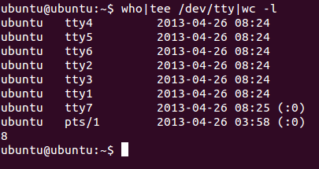

2. Output of ls should be displayed on the screen and from this output the lines containing word poem should be counted and the count should be stored in a file called file1.

Ans) ls|tee /dev/tty|grep –c poem>file1

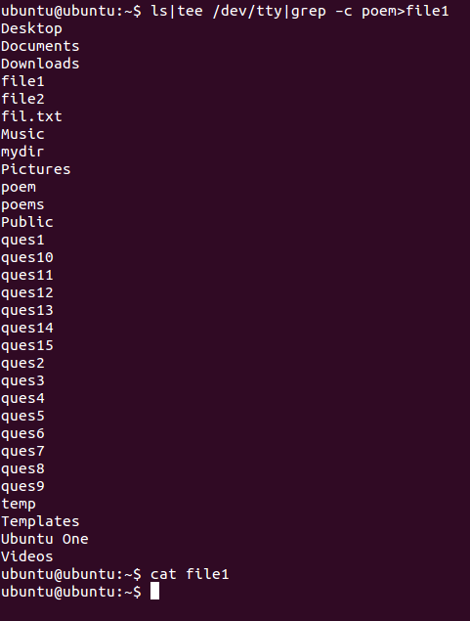

3. Contents of file1 and file2 should be displayed on the screen and this output should be appended to the file3.

Ans) cat one two|cat>>three

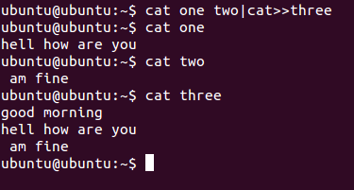

4. From output of ls the lines containing poem should be displayed on the screen along with the count.

Ans) ls|grep poem|tee /dev/tty|wc -l

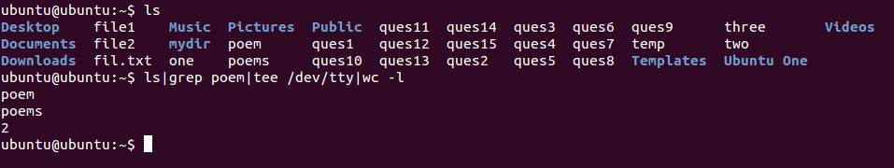

5. Name of cities should be accepted from the keyboard. This list of cities should be combined with the list of cities present in the file cityfile. This combined list should be sorted and the sorted output should be stored in a file newcity.

Ans) sort – city<<EOF|cat>newcity

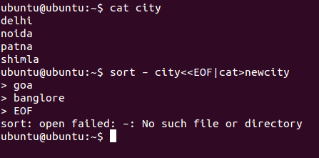

6. All files present in a directory dir1 should be deleted. Any error, if it occurs while carrying out this operation should be stored in a file errorlog.

Ans) rmdir dir1>errorlog

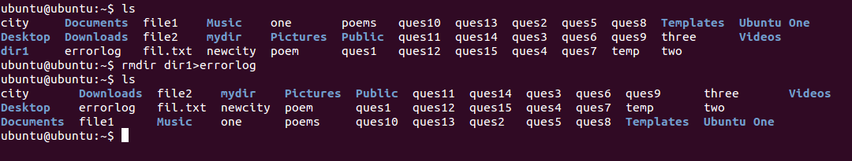

7. List of all files beginning with character P on the screen and also store them in a file called file1.

Ans) ls p*|tee /dev/tty>file1

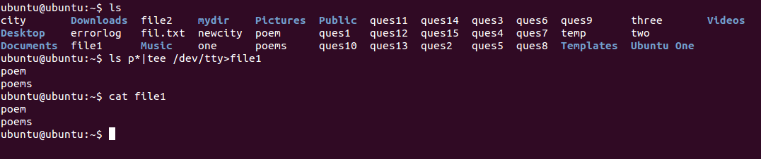

8. List of files beginning with character P on the screen twice in succession

Ans) ls p* |tee /dev/tty

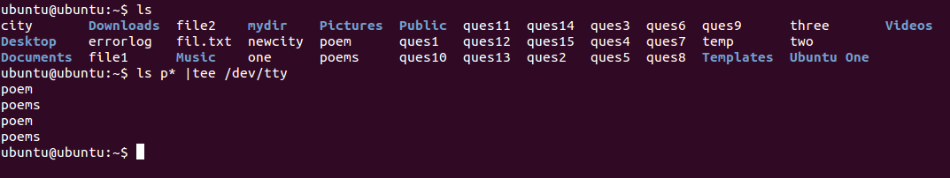

9. Merge the contents of the files a.txt, b.txt and c.txt, sort them and display the sorted output on the screen page by page.

Ans) sort a.txt b.txt c.txt|less

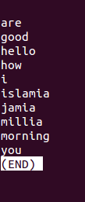

10. Display the list of last 20 files present in current directory. Also store them in a file called profile.

Ans) ls|tail > profile

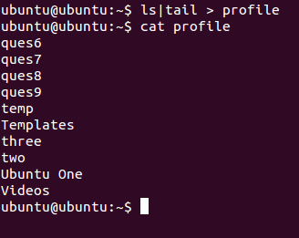

*Shell Scripts*

|  |  |
| --- | --- |
| 1 | Write a shell script which receives any year from the keyboard and determine whether the year is a leap year or not. If no argument is supplied the current year should be assumed |

echo Enter year:

read year

if [ -z $year ]

then

year=`date | cut -f 6 -d " "`

fi

num=`echo $year % 4 | bc`

if [ $num -eq 0 ]

then

echo $year is leap year.

else

echo $year is not a leap year.

fi

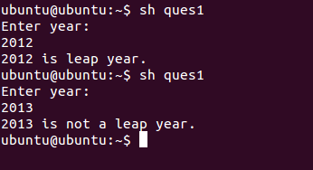

|  |  |
| --- | --- |
| 2 | Write a shell script which can receive an argument 'one', 'two', 'three'. If the argument supplied is 'one' display it in bold, if it is 'two' display it in reverse video and if it is 'three' make it blink on the screen. |

echo Enter one/two/three

read word

if [ $word = one ]

then

tput bold

echo one

tput init

elif [ $word = two ]

then

tput rev

echo two

tput init

elif [ $word = three ]

then

count=0

while [ $count -le 10 ]

do

clear

sleep 0.2

echo two

sleep 0.5

count=`expr $count + 1

done

fi

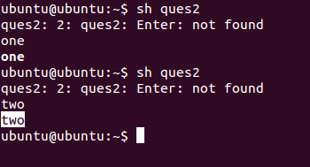

|  |  |
| --- | --- |
| 3 | Write a shell script which get executed the moment the user logs in. it should display the message “Good Morning”/”Good Afternoon”/”Good Evening” depending upon the time at which user logs in. |

check=`date +%H`

time=`date +%T`

echo $time

if [ $check -ge 06 -a $check -le 12 ]

then

echo "Good morning"

elif [ $check -ge 12 -a $check -le 16 ]

then

echo "Good afternoon"

else

echo "Good evening"

fi



|  |  |
| --- | --- |
| 4 | Write a shell script to count and report the number of entries present in each sub-directory mentioned in the path which is supplied as a command-line argument. |

sum=0

total=0

if [ $# -eq 0 ]

then

echo "Comman value not passed"

else

cd $1

ls >fil.txt

t=`cat fil.txt`

for a in $t

do

if [ -d $a ]

then

total=`ls -l $a | wc -l`

total=`expr $total - 1`

sum=`expr $sum + $total`

echo Entries in Sub-dir $a are $total

fi

done

echo Total entires present in this directory $sum

fi

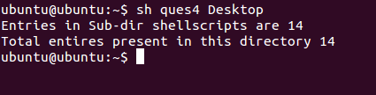

|  |  |
| --- | --- |
| 5 | Write a shell script to find the value of one number raised to the power of another number. |

echo Input number

read no

echo Input power

read power

counter=0

ans=1

while [ $power -ne $counter ]

do

ans=`expr $ans \* $no`

counter=`expr $counter + 1`

done

echo $no power of $power is $ans

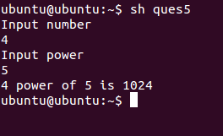

|  |  |
| --- | --- |
| 6 | Write a shell script which reports names and sizes of all files in a directory (directory would be supplied as an argument to the shell script) whose size is exceeding 1000 bytes. The file names should be printed in descending order of their sizes. The total number of such files should also be reported. |

if [ $# -gt 0 ]

then

cd $1

mkdir Temp

for a in *

do

size=`stat --format=%s "$a"`

if [ $size -gt 1000 ]

then

cp "$a" ./Temp/ 2>error

fi

done

ls -1S Temp/|tee /dev/tty|wc -l

rm -r Temp

rm error

fi

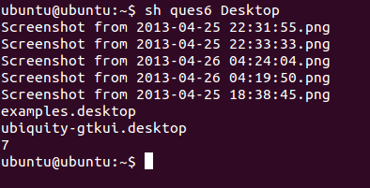

|  |  |
| --- | --- |
| 7 | Write a shell script which checks whether your friend has logged in or not. If your friend is logged in then send a message to your friend else check the status of your friend after every one minute up to five minutes. The log name should be supplied to the shell script at command prompt. |

if [ $# -gt 0 ]

then

user=$1

loggedin=`who|grep $user -c`

if [ $loggedin -gt 0 ]

then

`echo Hello!|write $user`

else

for a in 1 2 3 4 5

do

sleep 60

loggedin=`who|grep $user -c`

if [ $loggedin -gt 0 ]

then

`echo Hello!|write $user`

break

else

echo User $user still not logged in.

fi

done

fi

fi

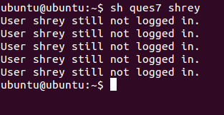

|  |  |
| --- | --- |
| 8 | Write a shell script to print all prime numbers from 1 to 1000. |

echo PRIME NUMBERS from 1-1000 are:

rng=1000

echo 2 "\c"

j=3

while test $j -le $rng

do

i=2

x=`expr $j - 1`

while test $i -le $x

do

if [ `expr $j % $i` -ne 0 ]

then

i=`expr $i + 1`

else

break

fi

done

if [ $i -eq $j ]

then

echo $j "\c"

fi

j=`expr $j + 1`

done

echo \n

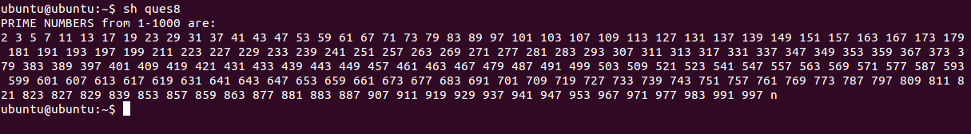

|  |  |
| --- | --- |
| 9 | Write a shell script to generate all the combinations of 1,2 and 3. |

echo "All combinations of 1 2 & 3 are:"

for i in 1 2 3

do

for j in 1 2 3

do

for k in 1 2 3

do

if test $i -ne $j -a $i -ne $k -a $j -ne $k

then

echo $i$j$k

fi

done

done

done

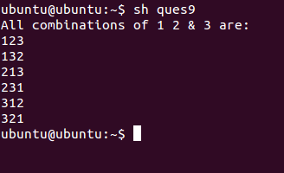

|  |  |
| --- | --- |
| 10 | Write a shell script which will receive a list of file names, the first of which would be wordfile (wordfile is a file that consists of several words). The shell script should report all occurrence of each word in word file in the rest of the files supplied as arguments. |

cp $1 temp

shift 1

for token in `cat temp`

do

echo Occurances of $token:"\c"

i=2

for i in $@

do

grep -c $token $i

done

done

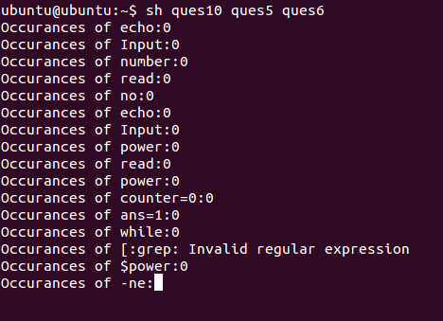

|  |  |
| --- | --- |
| 11 | Write a shell script which deletes all lines containing the word linux in the files supplied as arguments to this shell script. |

echo Enter file

read file

sed -e 's/linux//g' $file | cat >asdf.txt

cp asdf.txt $file

rm asdf.txt

cat $file

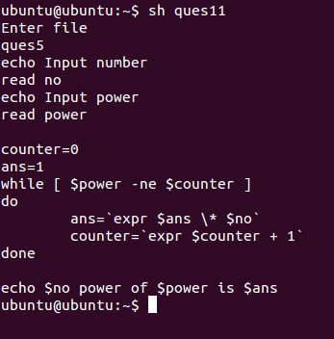

|  |  |
| --- | --- |
| 12 | Write a shell script which receives even number of file names. Suppose four file names are supplied then the first should get copied into second file, third should get copied into fourth file, and so on. If odd number of filenames are supplies then no copying should take place and an error message should be displayed. |

CheckNo=`expr $# % 2`

if [ $CheckNo -ne 0 ]

then

echo "ERROR: Even Number Of Arguments required.!!"

else

cnt=1

while [ $cnt -lt $# ]

do

cp $1 $2

shift

shift

cnt=`expr $cnt + 2`

done

fi

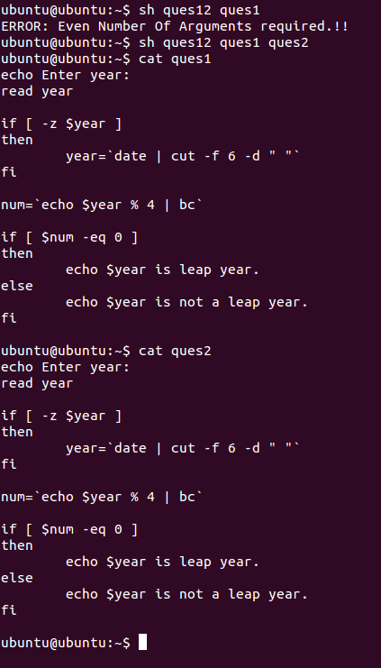

|  |  |
| --- | --- |
| 13 | Write a shell script which will receive any number of filenames as arguments. The shell script should check whether such files already exist. If they do, then it should be reported. If these files do not exist then check if a sub-directory called mydir exists in the current directory. If it doesn't exist then it should be created and in it the files supplied as arguments should get created. If mydir already exists then it should be reported alonf with the number of files that are currently present in mydir.  count=0  for i in $*  do  if [ -f $i ]  then  echo "File $i is already exist."  else  if [ -d mydir -a $count -lt 1 ]  then  count=0  else  if [ $count -eq 0 ]  then  mkdir mydir  count=1  echo DIRECTORY "mydir" has been made  fi  cd mydir> $i  echo file $i made  cd ..  fi  fi  done  if [ $count -eq 0 ]  then  cd mydir  for j in `ls`  do  if [ -f $j ]  then  count=`expr $count + 1`  fi  done  echo "Mydir already exist...contains $count files"  fi |
|  |  |

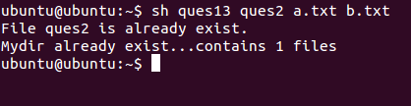

|  |  |
| --- | --- |
| 14 | Write a shell script which works similar to the wc command. This script can receive the option -l, -w, -c to indicate whether number of lines, number of words, or number of characters from the input stream are to be counted. The user may use any or all of these options. Your script should be intelligent to identify invalid options and reject them. |

l=0

w=0

c=0

echo Enter the Text. TO SToP TYPE end

k=1

ch=1

while [ $ch -gt 0 ]

do

read data

if [ "$data" = "end" ]

then

break

fi

if [ $k -eq 1 ]

then

echo $data>file2

k=`expr $k + 1`

else

echo $data>>file2

fi

l=`expr $l + 1`

for a in $data

do

if [ "$a" != "end" ]

then

w=`expr $w + 1`

else

echo yes

ch=0

break

fi

done

done

c=`ls -l file2|cut -f 5 -d ' '`

c=`expr $c - $l`

if [ $ch -eq 0 ]

then

c=`expr $c - 3`

fi

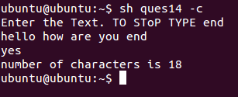

|  |  |
| --- | --- |
| 15 | Write a function mkcd() which would create all the directories present in the path supplied to it as argument and change over to the last directory in this path. Thus,  $ mkcd a1/a2/a3/a4/a5  should create the five nested directories and change the present working directory to a5.  mkcd()  {  dir=$1  mkdir -p $dir  cd $dir  pwd  }  if [ $# -gt 0 ]  then  mkcd $1  else  echo Path required  fi |

